**REPORT**

**ON**

**MEETRACK**

**‘An Agile Development tool’**

Department of Computer Engineering & Applications

Institute of Engineering & Technology

GLA University

Mathura- 281406

**Submitted by: Submitted to:**

Krishna Kant Sharma (181500332) Md.Farman Sir

Akashi Gupta(181500061) (Mentor)

Priyanshu Shukla (181500515)

** G.L.A UNIVERSITY**

**MATHURA, UTTAR PRADESH**

**Session: 2020-21**

**DECLARATION**

I hereby declare that the work which is being presented in the Mini Project **“Meetrack”,** in fulfilment of the requirements for Mini project Lab is an authentic record of our own work carried under the supervision of **Md.Farman, Technical Trainer.**

KrishnaKant Sharma

Priyanshu Shukla

Akashi Gupta

**ACKNOWLEDGEMENT**

It gives us a great sense of pleasure to present the report of the Project Work, undertaken during B. Tech, III Year. We owe special debt of gratitude to **Md. Farman, Technical Trainer,** Department of Computer Science &Technology, GLA University, Mathura for his constant support and guidance throughout the course of our work. His sincerity, thoroughness and perseverance have been a constant source of inspiration for us. It is only his cognizant efforts that our endeavours have seen light of the day. We also do not like to miss the opportunity to acknowledge the contribution of all faculty members of the department for their kind assistance and cooperation during the development of our project. Last but not the least, we acknowledge our friends for their contribution in the completion of the project.

Krishna Kant Sharma(181500332)

Priyanshu Shukla(181500515)

Akashi Gupta(181500061)

**INDEX**

**#Title**

Abstract

1.Introduction

2.Objective

3.Problem Statement

4.Hardware Requirements

5. Software Requirements

6.Technologies Used

7.Implementation Details

8.Screenshots

9.References

**Abstract**

Team building involves a wide range of activities, designed for improving team performance. Its aim is to bring out the best in a team to ensure self development, positive communication, leadership skills  and the ability to work closely together as a team to problem solve. Attractions and challenges of implementing teams so as  to give a  realistic preview of what can be achieved through teamwork. To keep track of work we need to some source of tool here we present Meetrack the tool to keep track of all of your work

INTRODUCTION

Agile is a term used to describe approaches to software development emphasizing **incremental delivery, team collaboration, continual planning, and continual learning**, instead of trying to deliver it all at once near the end.

Agile focuses on **keeping the process lean and creating minimum viable products (MVPs)** that go through a number of iterations before anything is final. Feedback is gathered and implemented continually and in all, it is a much more **dynamic process** where everyone is working together towards one goal.

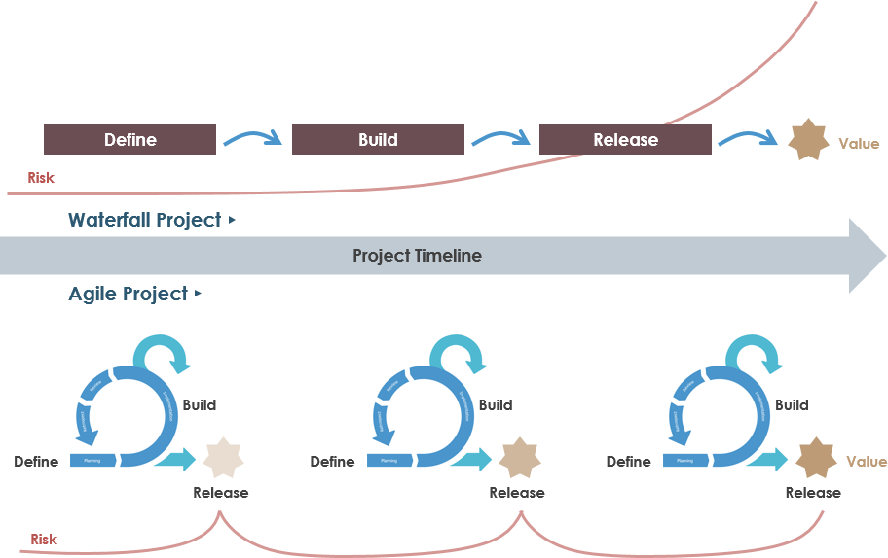

**Scrum :**

Scrum is a framework within which people can address complex adaptive problems, while productively and creatively delivering products of the highest possible value. It is used for managing software projects. Its focus is on an adaptive product development strategy where a cross-functional team works as a unit to reach a common goal within 2-4 weeks called **SPRINT**.

**Lean :**

Lean founded new applications in **knowledge work, helping businesses in all industries *eliminate waste, improve processes, and boost innovation*.** Software development is a natural application of Lean methodology because, much like manufacturing, it generally follows a defined process, has some defined conditions of acceptance, and results in the delivery of tangible value.

The key concepts that guide all practice of Lean methodology, which we call the Pillars of Lean. They are:

* **Continuous improvement**
* **Respect for people**
* **Lightweight Leadership**.

**Usecase Diagram**

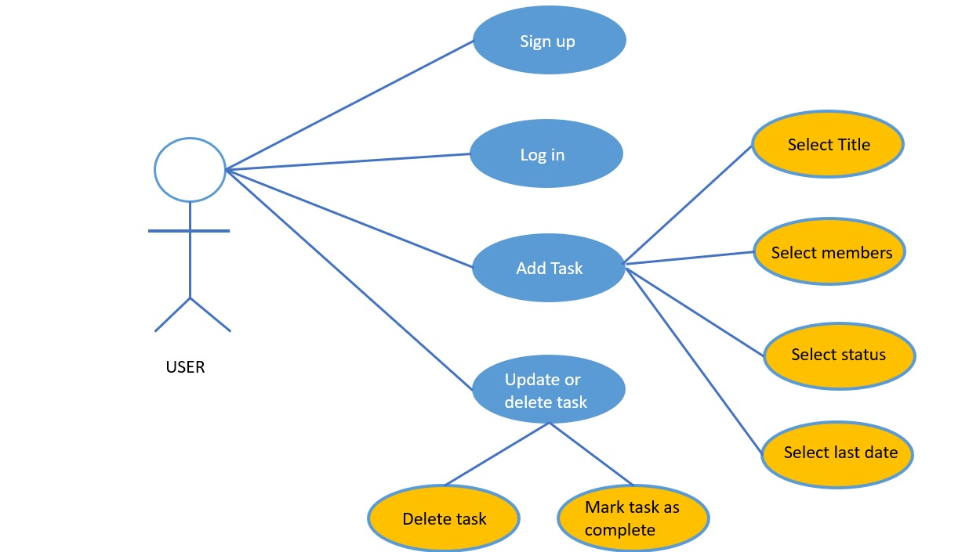

OBJECTIVE

The objective is to build a web portal in working condition by considering the following details :

* **Signup**
* **Login**
* **Dynamic Dashboard**
* **Profile**

Most of the Software industries are facing problems regarding the completion of projects with absolute customer satisfaction and time management. Though we have so many other methods to develop a project (software) and deliver it to the customer but none of them get developed  trust between customer and company.

Most of them lost time tracking and quality.Beside this there is no other strategy able to accept change or if it does, it takes too much time and cost to modify it.

Hence to overcome this problem we present you, the tool to implement agile software  development methodologies efficiently and effectively.

In agile methodology we provide absolute **Customer satisfaction** by **rapid, continuous delivery** of useful **software**. People and interactions are **emphasized** rather than process and tools. Customers, developers and testers **constantly interact** with each other. Working **software** is delivered frequently (weeks rather than months).

PROBLEM STATEMENT

Most of the Software industries are facing problems regarding the completion of projects with absolute customer satisfaction and time management. Though we have so many other methods to develop a project (software) and deliver it to the customer but none of them get developed  trust between customer and company.

Most of them lost time tracking and quality.Beside this there is no other strategy able to accept change or if it does, it takes too much time and cost to modify it.

Hence to overcome this problem we present you, the tool to implement agile software  development methodologies efficiently and effectively.

In agile methodology we provide absolute **Customer satisfaction** by **rapid, continuous delivery** of useful **software**. People and interactions are **emphasized** rather than process and tools. Customers, developers and testers **constantly interact** with each other. Working **software** is delivered frequently (weeks rather than months).

HARDWARE REQUIREMENTS

Ram : 8Gb,4Gb(min)

Processor : i3 5th generation or higher

SOFTWARE REQUIREMENTS

* Chrome Web browser or any other
* Sqlite editor
* Vs code/pycharm
* Git
* Github
* Django SDK
* Internet connection

TECHNOLOGIES USED

* **Front End Design :**

To design the layout of the web application we are using HTML,CSS,django and BOOTSTRAP, JAVASCRIPT and chrome web browser. also Visual studio provides extensions to directly view the layout.

* **Database :**

For Storing User Data and authentication we are using sqlite as it stores data in tables  which is easy to access and readable

* **Back End Design :**
* Django
* Python
* Sqlite

IMPLEMENTATION DETAIL

* we have used HTML, CSS, Javascript, Bootstrap, django, nosql in this project
* first of all we created signup page from which user will create account
* it takes a username(unique) and a strong password which will save in database as user record
* we have used django authentication system to check password strength
* after that we created a login page from which user will enter to dashboard
* we used django form in this page to provide strong and secure authentication system
* now the details given by user will compare with database user record if matched then user will enter to dashboard otherwise a popup message appear
* now when user enters into dashboard he/she can add task to there dashboard
* while adding task it will ask task title lastdate status and number of members to the user
* after click on add task button the task will added to task list and data will be saved to task database
* now user can delete aur mark done the task
* after that we created 2 more pages about and contact
* about is a static page it has all the team deatails profile links etc...
* contact page also have some links to contact us but also have a form which will take user name and a text message for our team this data will save in to third table.

SCREENSHOT

* **Source Screenshot:**

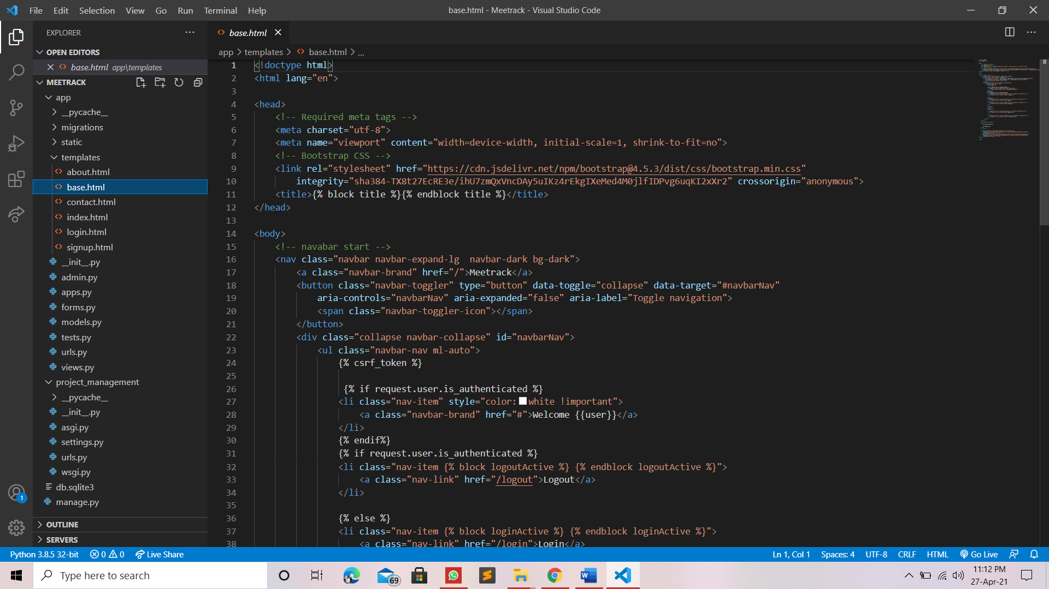

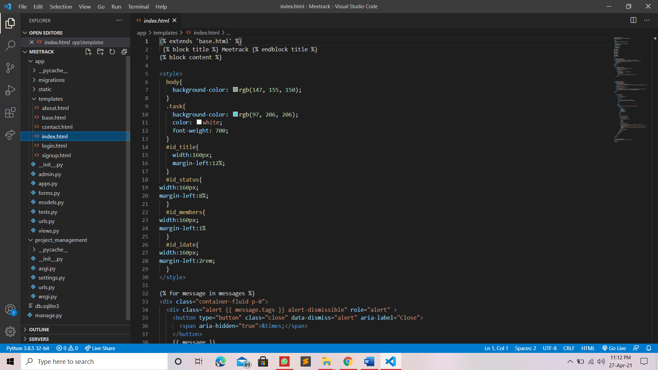

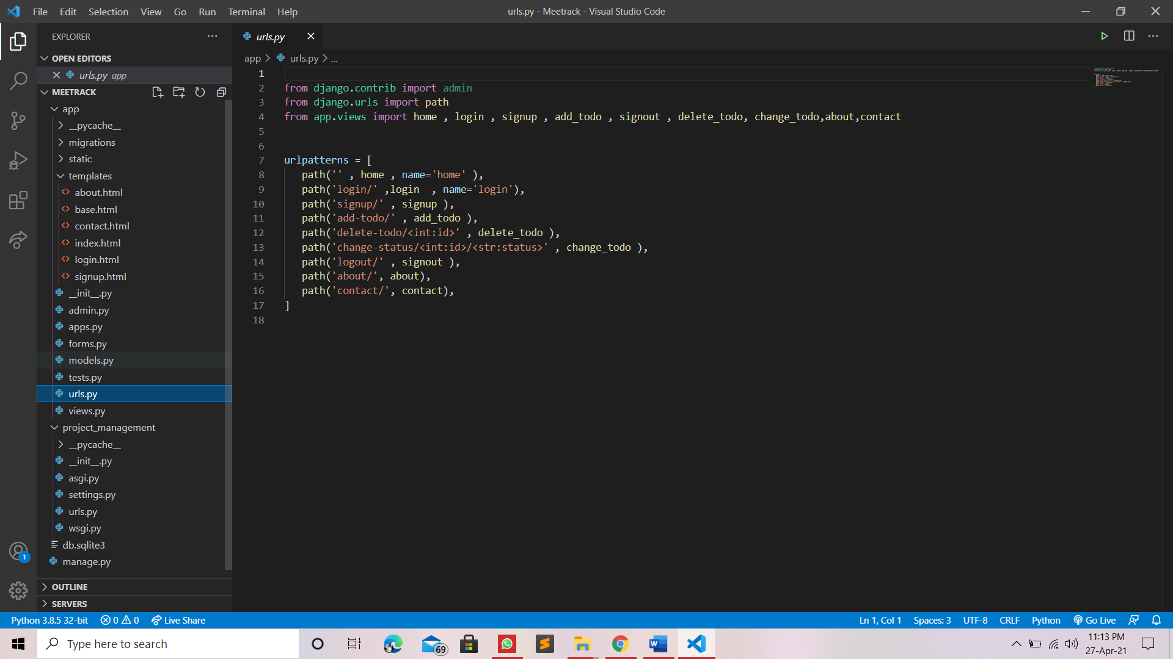

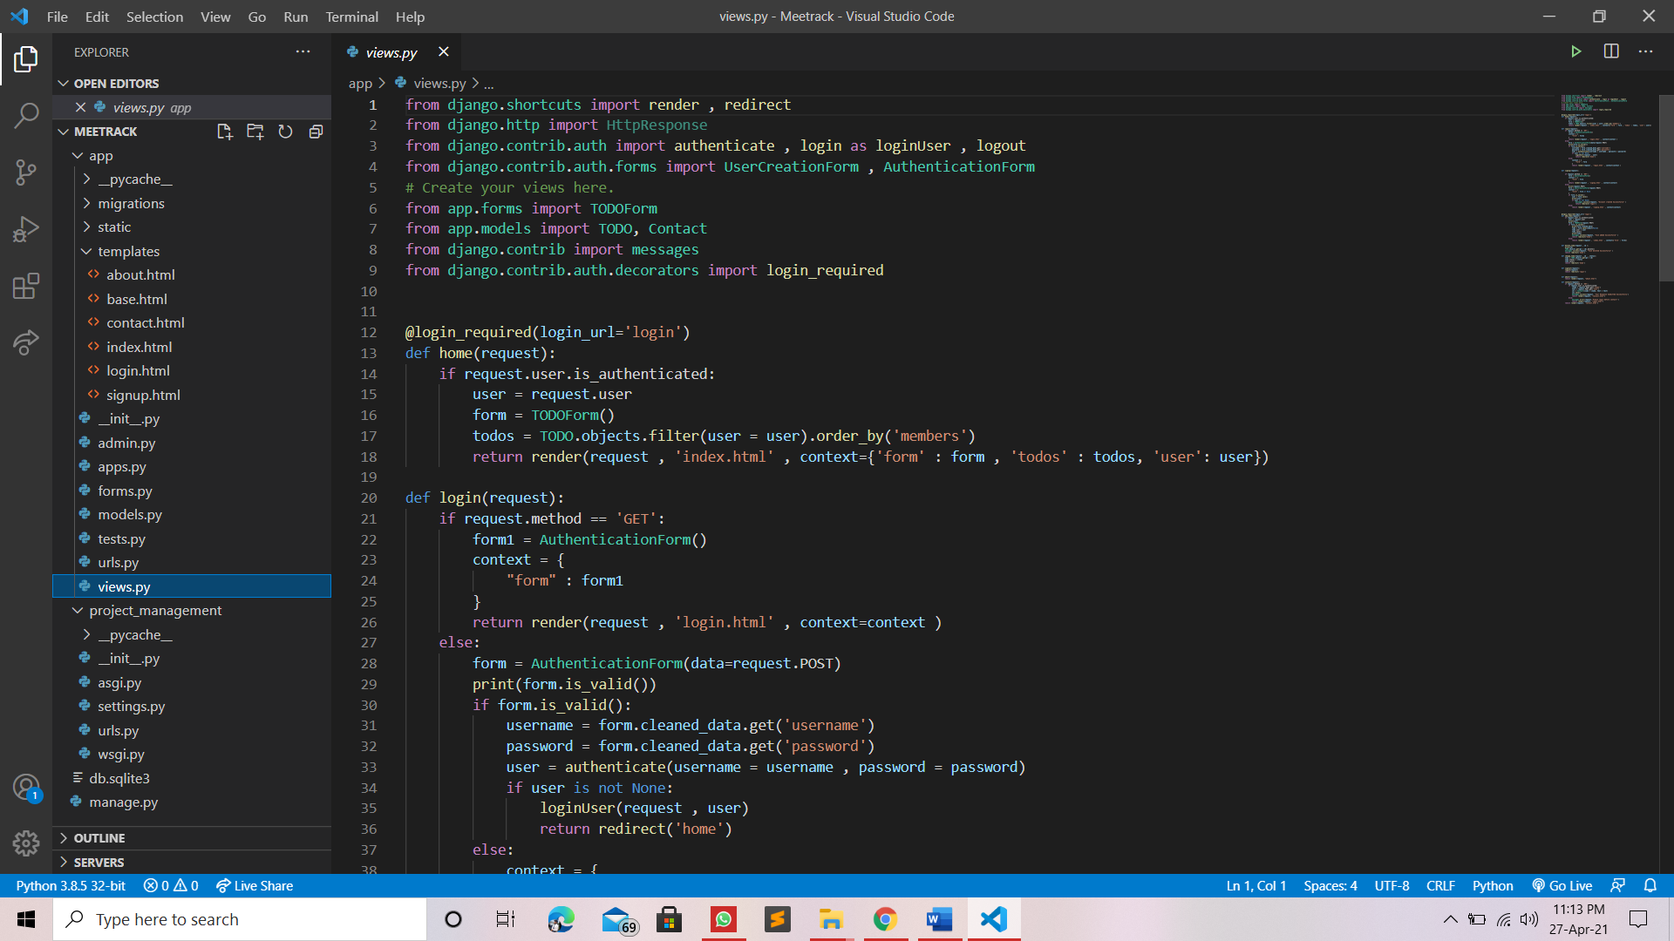

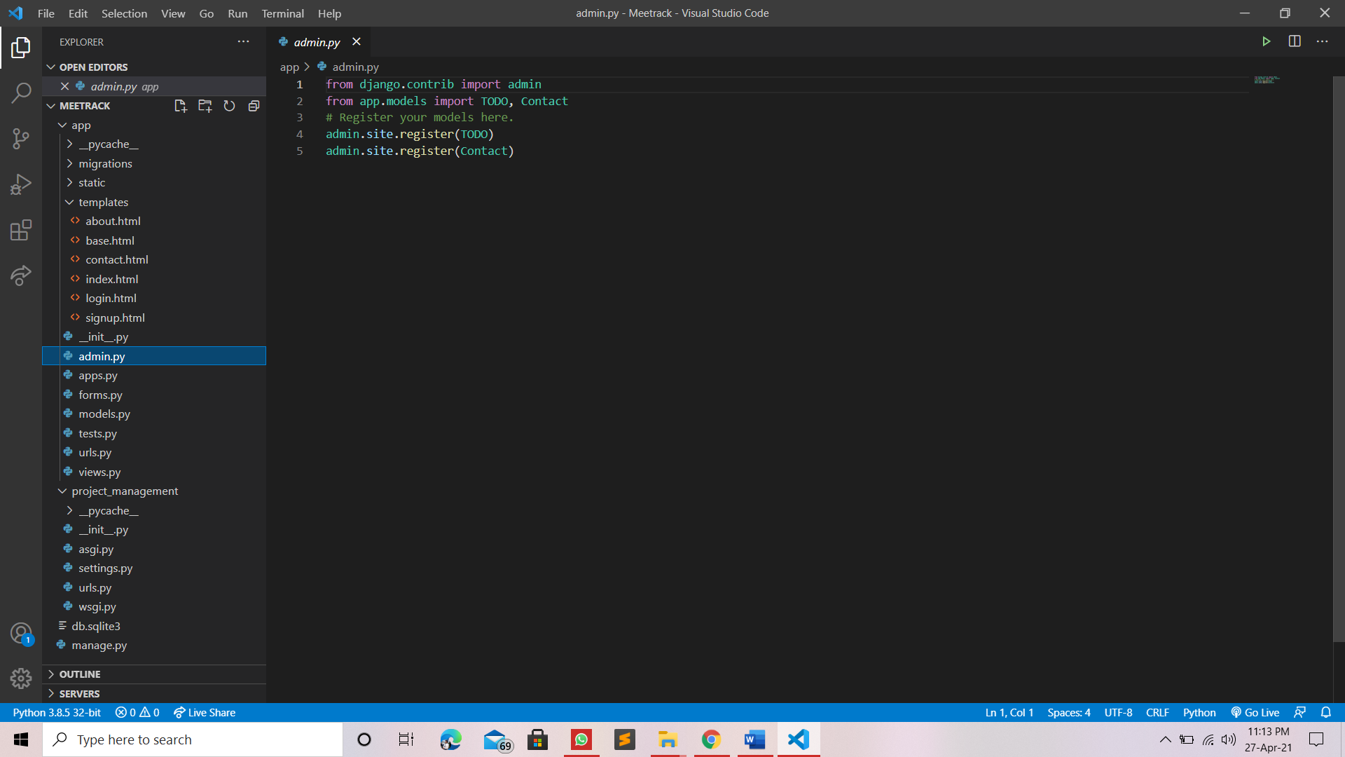

* **User Interface**

**LogIn**

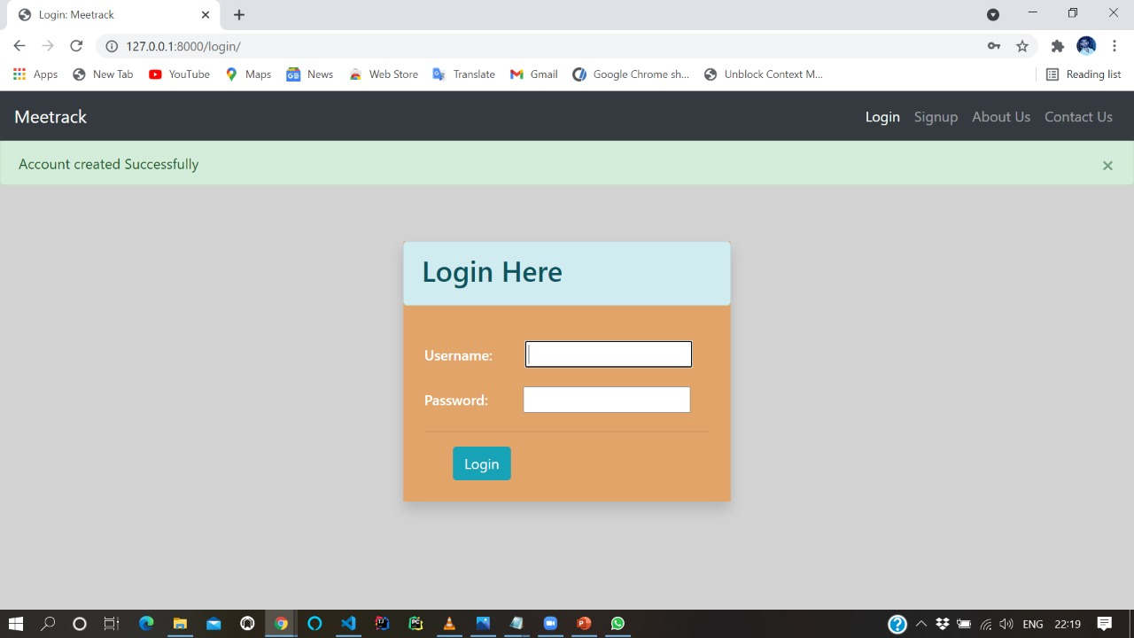

**SignUp**

In this template we can create our account

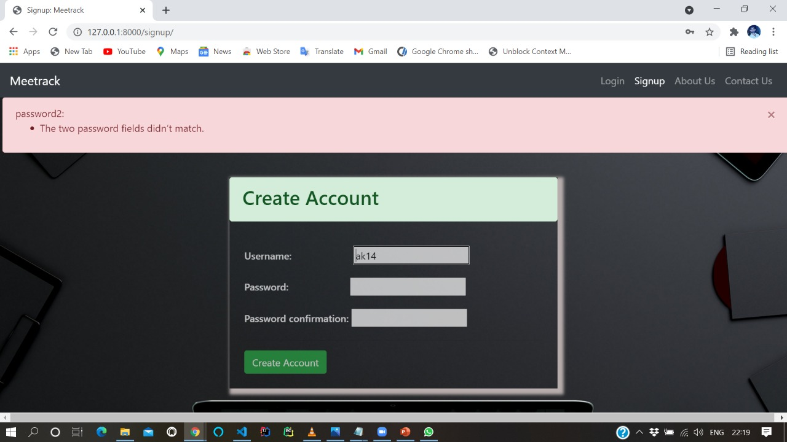

**Home Page**

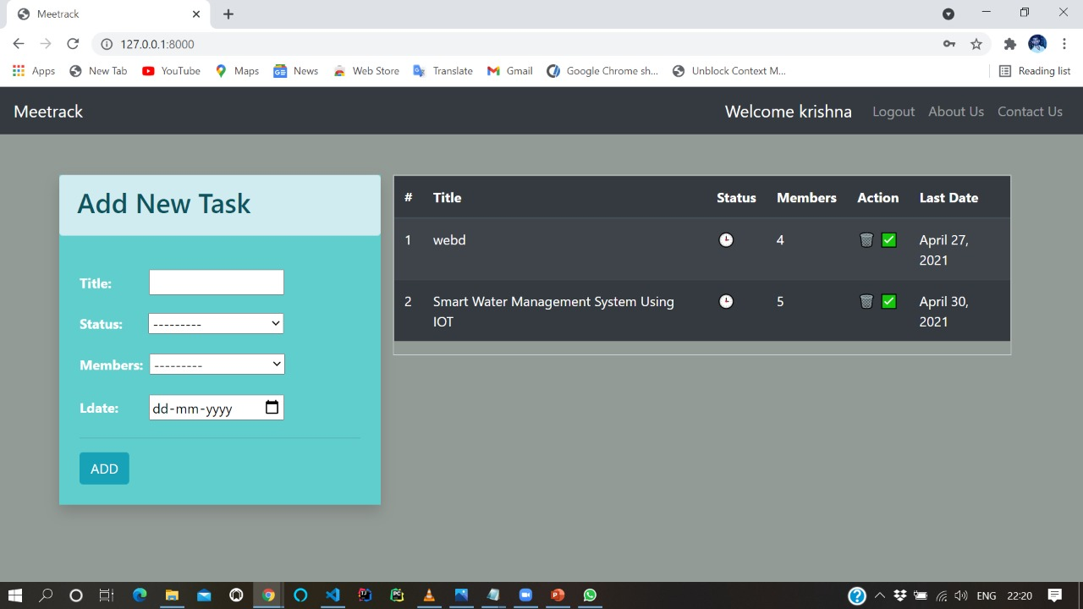

**Task Assignment**

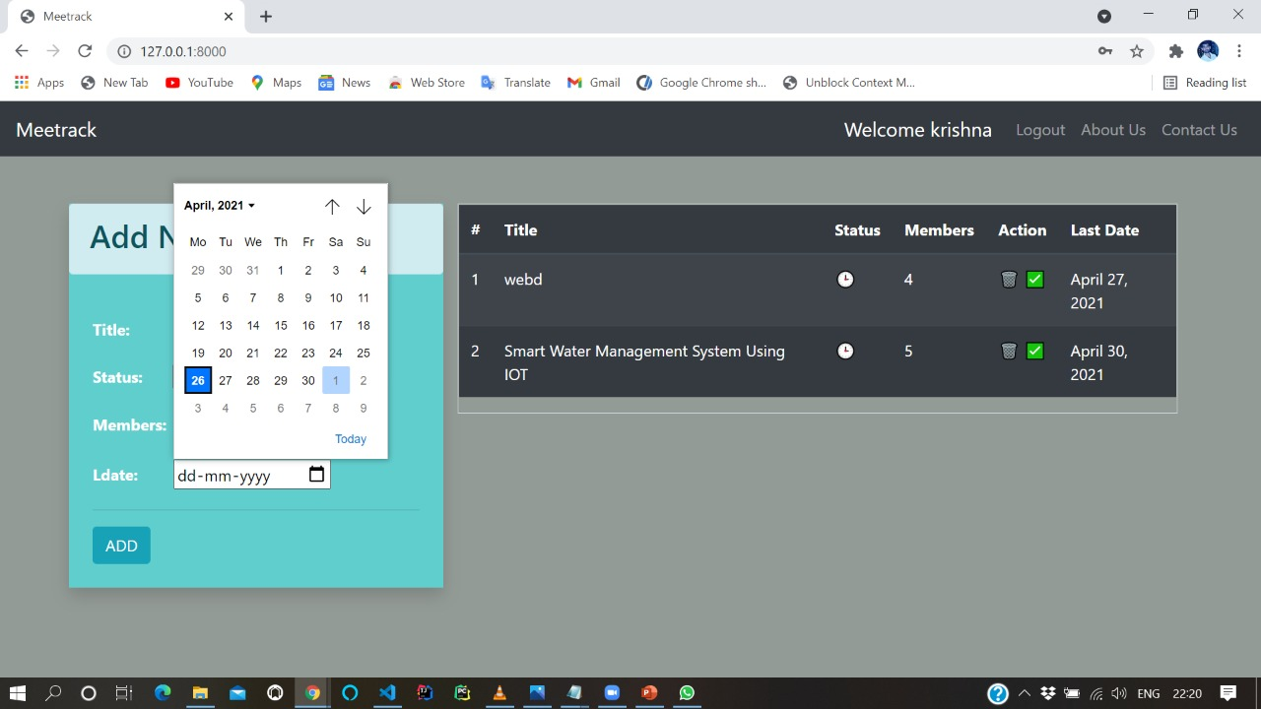

**About Us**

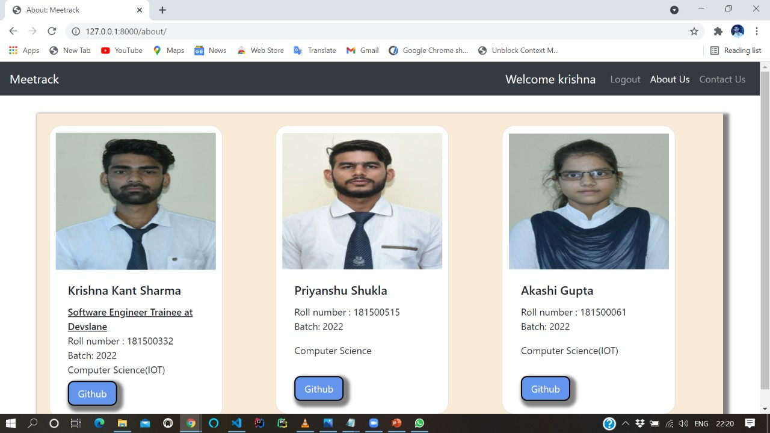

**Contact Us**

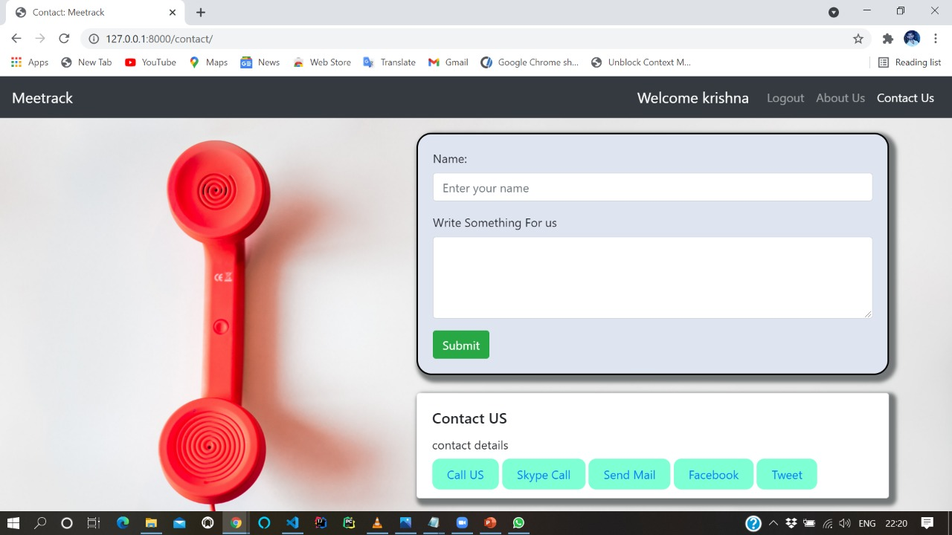

REFERENCES

* [**Django documentation**](https://reactjs.org/docs/getting-started.html)
* [**SQlite Documentation**](https://nodejs.org/en/docs/)
* [**code with uncle bob (blog)**](https://www.tutorialspoint.com/index.htm)
* [**Stack Overflow**](https://stackoverflow.com/)
* [**bootstrap documentation**](https://getbootstrap.com/docs/4.0/getting-started/introduction/)